Mini Project Report on

**CRIMINAL DETECTION**

**(CAM-RADAR)**

Submitted by

|  |  |  |
| --- | --- | --- |
| Name of Student | Class | Roll No. |
| 1. Pranav Makwana | TE3 | 68 |
| 2. Bhavya Parmar | TE3 | 69 |
| 3. Mihir Vaidya | TE3 | 76 |

Under the guidance of

Prof. Krupa Chotai



## DEPARTMENT OF COMPUTER ENGINEERING SHAH AND ANCHOR KUTCHHI ENGINEERING COLLEGE

CHEMBUR, MUMBAI - 400088.

2019-2020

[**www.shahandanchor.com**](http://www.shahandanchor.com/) **Tel: 022 2558 0854**

**Mahavir Education Trust’s**

## SHAH ANCHOR KUTCHHI ENGINEERING

COLLEGE

**Mahavir Education Trust Chowk, W.T. Patil Marg, Chembur, Mumbai 400 088**

Affiliated to University of Mumbai, Approved by D.T.E. & A.I.C.T.E.

Awarded accreditation for Computer & Information Technology Engineering by NBA

(for 3 years w.e.f. 1st July, 2019)

Certificate

This is to certify that the report of the mini project entitled

**CRIMINAL DETECTION**

**(CAM-RADAR)**

is a bonafide work of

|  |  |  |
| --- | --- | --- |
| Name of Student | Class | Roll No. |
| 1. Pranav Makwana | TE3 | 68 |
| 2. Bhavya Parmar | TE3 | 69 |
| 3. Mihir Vaidya | TE3 | 76 |

submitted to the

**UNIVERSITY OF MUMBAI**

during semester VI in

### COMPUTER ENGINEERING DEPARTMENT

|  |  |
| --- | --- |
|  |  |
| (PROFESSOR KRUPA CHOTAI) | (PROFESSOR UDAY BHAVE) |
| GUIDE | I/C HEAD OF DEPARTMENT |

# Approval for Mini Project Report for T. E. Semester VI

This mini project report entitled “CRIMINAL DETECTION

(CAM-RADAR)” by Student 1, Student 2, and Student 3 is approved for the partial fulfillment of the requirement for the completion of Semester VI.

Name and Sign of Internal Examiner

Name and Sign of External Examiner _____ _

Date:Place:

# Declaration

We declare that this written submission represents our ideas in our own words and where others' ideas or words have been included, we have adequately cited and referenced the original sources. We also declare that we have adhered to all principles of academic honesty and integrity and have not misrepresented or fabricated or falsified any idea/data/fact/source in our submission. We understand that any violation of the above will be cause for disciplinary action by the Institute and can also evoke penal action from the sources which have thus not been properly cited or from whom proper permission has not been taken when needed.

|  |  |  |  |
| --- | --- | --- | --- |
| Name of Student | Class | Roll No. | Signature |
| 1. Pranav Makwana | TE3 | 68 | _ _ _ _ _ _ |
| 2. Bhavya Parmar | TE3 | 69 | _ _ _ _ _ _ |
| 3. Mihir Vaidya | TE3 | 76 | _ _ _ _ _ _ |

Date:13th May,2021.

# Attendance Certificate

To,

The Principal

Shah and Anchor Kutchhi Engineering College, Chembur, Mumbai-88

Date

Subject: Confirmation of Attendance

Respected Sir,

This is to certify that Third year (TE) students (Names of Students)

have duly attended the sessions on the day allotted to them during the period from

8th January to 12th May for performing the Mini Project titled Criminal Detection (Cam-Radar)

They were punctual and regular in their attendance. Following is the detailed record of the student’s attendance.

Attendance Record:

|  |  |  |  |
| --- | --- | --- | --- |
| Date | Pranav Makwana | Bhavya Parmar | Mihir Vaidya |
| Present/Absent | Present/Absent | Present/Absent |
| 8/01/2020 | Present | Present | Present |
| 15/01/2020 | Present | Present | Present |
| 22/01/2020 | Present | Present | Present |
| 29/01/2020 | Present | Present | Present |
| 05/02/2020 | Present | Present | Present |
| 4/03/2020 | Present | Present | Present |
| 11/03/2020 | Present | Present | Present |
| 18/03/2020 | Present | Present | Present |
| 01/04/2020 | Present | Present | Present |
| 15/04/2020 | Present | Present | Present |

Signature and Name of Internal Guide

**Abstract:**

Human face detection and recognition play important roles in many applications like video

surveillance and face image database management.

In our project, we've studied worked on both face recognition and detection techniques and

developed algorithms for them. In face recognition we have used is LBPH (Local Binary

Pattern Histogram)easy to understand and also it is very simple and efficient texture operator which labels the pixels of a picture by thresholding the neighborhood of every pixel and considering the result as a binary number.

It was first described in 1994 (LBP) and has since been found to be a strong feature for texture

classification. it's further been observed that when we combined LBP with histograms of oriented gradients (HOG) descriptor, it improves the detection performance considerably on some datasets.

With the help of LBP combined with histograms it will represent the face images along with an easy data vector.

These technique works perfectly well under robust conditions like different face positions, complex background. These algorithms provides different rates of accuracy for different conditions as experimentally observed. In face detection, we've developed an algorithm which will detect human faces from a picture.

**Table of Content:**

1. Abstract 6
2. Table Of Content……………………………………………………………………………………...7
3. List of Figures 8
4. Chapter 1:

1.1 Introduction……………………………………………………………………………………….9

1. Chapter 2:

2.1 Literature Survey…………………………………………………………………………………10

1. Chapter 3:

3.1 Problem Statement………………………………………………………………………………..14

3.2 Objective………………………………………………………………………………………….14

1. Chapter 4:

4.1 System Block Design……………………………………………………………………………..15

4.2 Flowchart…………………………………………………………………………………………16

4.3 Algorithm…………………………………………………………………………………………17

1. Chapter 5:

Design Implementation

5.1 Module 1- dataCreator.py…………………………………………………………………………21

5.2 Snapshots………………………………………………………………………………………….21

5.3 Module2 – FaceTrain.py…………………………………………………………………………..23

5.4 Snapshots………………………………………………………………………………………….24

5.5 Module3—FaceDetect.py…………………………………………………………………………28

5.6 Snapshots………………………………………………………………………………………….29

1. Chapter 6:

6.1 Conclusion…………………………………………………………………………………………33

6.2 Future Scope………………………………………………………………………….……………34

References & Acknowledgement…………………………………………………………………………..35

**List of Figures:**

Figure 1: System Block Design……………………………………………………………….…..15

Figure 2: Flowchart Diagram ……………………………………………….…………………....16

Figure 3: LBPH Flowchart Design…………………..……………………………………….…..18

Figure 4: Face Window…………………………………………………………………………..19

Figure 5: Threshold Conversion…………………………………………………………….……20

Figure 6: LBPH Conversion……………………………………………………………….……..21

Figure 7: Snap-shot of dataCreator.py(1)……………………………………………….………..22

.

Figure 8: Snap-shot of dataCreator.py(2) ………………………………………………….…….23

Figure 9: Snap-shot of dataCreator.py(3) ……………………………………………….……….24

Figure 10: Snap-shot of FaceTrain.py(1) ……………………………………….………………..24

Figure 11: Snap-shot of FaceTrain.py(2) ……………………………………………….………..25

.

Figure 12: Snap-shot of FaceTrain.py(3) …………………………………….……….………….26

Figure 13: Snap-shot of FaceTrain.py(4) …………………………………….……….………….27

Figure 14: Snap-shot of FaceDetect.py(1) …………………………………………………….…29

Figure 15: Snap-shot of FaceDetect.py(2) ……………………………………………………….30

Figure 16: Snap-shot of FaceDetect.py(3) ……………………………………………………….31

Figure 17: Snap-shot of FaceDetect.py(4) ………………………………………………………..32

**Chapter 1:**

**1.1 Introduction**

The face is our primary focus of attention in social life playing an important role in conveying identity and emotions. We can recognize a number of faces learned throughout our lifespan and identify faces at a glance even after years of separation. This skill is quite robust despite of large variations in visual stimulus due to changing condition, aging and distractions such as beard, glasses or changes in hairstyle.

Computational models of face recognition are interesting because they can contribute not only to theoretical knowledge but also to practical applications. Computers that detect and recognize faces could be applied to a wide variety of tasks including criminal identification, security system, image and film processing, identity verification, tagging purposes and human-computer interaction. Unfortunately, developing a computational model of face detection and recognition is quite difficult because faces are complex, multidimensional and meaningful visual stimuli.

Face detection is used in many places now a days especially the websites hosting images like picassa, photobucket and facebook. The automatically tagging feature adds a new dimension to sharing pictures among the people who are in the picture and also gives the idea to other people about who the person is in the image. In our project, we have studied and implemented a pretty simple but very effective face detection algorithm which takes human skin colour into account.

Our aim, which we believe we have reached, was to develop a method of face recognition that is fast, robust, reasonably simple and accurate with a relatively simple and easy to understand algorithms and techniques. The examples provided in this thesis are real-time and taken from our own surroundings.

***Chapter 2:***

**Chapter 2:**

**Literature Review**

|  |  |  |  |
| --- | --- | --- | --- |
| **Sr.No.** | **Author/Title/Year** | **Work done/Algorithm/Concept/Idea presented in the paper** | **Remarks** |
| 1. | Ratna Yustiawati,Nyayu Latifah Husni,Evelina Evelina,Sabilal Rasyad,Iskandar Lunitfi,Ade Silvia,Niksen Alfarizal and Adella Rialita, ‘Analyzing Of Different Features Using Haar Cascade Classifier’. Pangkal Pinang: IEEE,2019. | This paper talks about Haar Cascade and how it is used in face detection. Face recognition is used for identifying a face by digital means. Haar cascade classifier algorithm is used for training images and detecting faces. This method was usually used because it gave advantages, such as high accuracy and fast compution. It has simple value of features and just depends on the amount of pixels inside the square, not the value of pixels of an image. | Despite unfavorable detection results mentioned within the paper the Haar Cascade Classifier algorithm has potential to deliver respectable results. We could scan images over greater scale to attenuate miss rate and detect faces more accurately. We could implement this algorithm during a more low level language like MATLAB or C++ to attenuate training and testing times and enhance the speed at which we perform experiments. |
| 2. | Neel Ramakant Borkar and Sonia Kuwelkar, ‘ Real-time implementation of face recognition system’. Erode, India: IEEE,2017 | Everyone has had the experience of not recognizing someone they know due to changes in pose, facial expressions, illumination and expressions. So it's not surprising that computer vision system may face the same problems. Despite of years of work on computer vision scientists from all over the world are not able to match that of human performance. The best systems can overrun human performance under fixed ideal condition. But the performance decreases drastically as conditions change. In this paper a combination of PCA and LDA algorithm have been proposed to implement Face Recognition System on Raspberry pi 3. PCA and LDA algorithms project all the training AT&T dataset images onto eigen space. For the recognition purpose the Euclidean Distance is calculated between the test image and all the training images. The trained image that has minimum Euclidean distance to test image ie. unknown image is the correct match. | The algorithm was applied to AT&T dataset of 100 training images of 20 persons taking 5 images of each person for training purpose. The accuracy of FACE RECOGNITION using PCA alone was found to be 91%, the accuracy of LDA alone was found to be 94% and that of proposed method was found to be 97% when implemented on raspberry pi 3 board. This paper shows that combining two or more methods increase the accuracy of Face Recognition System. In future this system can be incorporated into humans to make it more human like. |
| 3. | Maliha Khan,Sudeshna Chakraborty,Rani Astya and Shaveta Khepra, ‘Face Detection and Recognition Using OpenCV’. Greater Noida, India: IEEE,2019. | This paper mainly focuses on the face detection and picture or video recognition that is a popular subject of research on biometrics. Face recognition in a real-time setting has an exciting area and a rapidly growing challenge.This proposes the PCA (Principal Component Analysis) facial recognition system.The aim of the PCA is to reduce the large amount of data storage into size of the feature space that is required to represent the data economically. Wide 1-D pixel vector that are made of the 2-D face picture in compact main elements of the space function is designed for F.R by the PCA. This is called a projection of self-space. | In the last 20 years, facial recognition technology has come a long way. Today we can check identity information automatically with regard to safe transactions, tracking, security purposes and buildings access control. Such systems normally work in controlled environments and algorithms of recognition may manipulate environmental constraints to achieve high accuracy of recognition. Yet face-recognition technologies of next generation will be commonly used in smart settings where computers and machines are more like supportive helpers. |
| 4. | Aftab Ahmed,Jiandong Guo,Fayaz Ali,Farha Deeba and Awais Ahmed, ‘ LBPH based improved face recognition at low resolution’ .Chengdu, China:IEEE,2018. | This paper employs the Local Binary Patterns Histogram (LBPH) algorithm architecture to deal with the face recognition in real time at the low level of resolution.Automatic individual face recognition is the most challenging task from the past decade in computer vision. However, the enforcement agencies are inadequate to spot and recognize a person through the video monitoring cameras further efficiently. The extreme conditions like blur conditions, resolution, lighting and illumination are still the main problems in face recognition. | While in Face representation describes the input of face behaves and moreover, it limits the algorithms for the detection and recognition. Further, for feature extraction, this LBPH histogram found a completely unique result and eventually we classify input detected face compare with the proposed dataset.In future, this proposed approach are going to be more beneficial for security agencies to spot criminals, whose have record in database. it'll help to acknowledge any unknown or known person in surveillance area at low resolutions thanks to long distance of camera and observed subject. |
| 5. | Lu Song and Fuan Wen, ‘ The Human-Computer Interaction Design and Research of Virtual Experiment’. Hangzhou, China: IEEE,2014. | This paper introduces the main content of the human-computer interaction of virtual experiment, and put forward to improve the design principles of the performance of interface interaction, combined with the case analysis of "the pen online virtual laboratory of BUPT ", the paper proposes some suggestions to improve human-computer interaction design of virtual experiment. | This paper analyzes the theoretical basis and the main contents for the design of human-computer interaction, proposed some instructive principles, and will be used to develop its "Open Online Virtual Laboratory of BUPT " in some experiments, the preliminary trial of the system has been welcomed and recognized by students. Some deficiencies to be improved and enhanced, I believe that through continuous exploration and practice, in the future, the virtual experiment system will be more autonomous, intelligent, humane, and will give learners a better operating experience and cognitive experience. |
| 6. | Ali Sharifara,Mohd Shafry Mohd Rahim and Yasaman Anisi, ‘ A general review of human face detection including a study of neural networks and Haar feature-based cascade classifier in face detection’. Kuala Lumpur, Malaysia: IEEE,2014. | This paper focuses on up-to-date review of face detection methods including knowledge-based, template matching,eature-based and appearance-based. Also, the study presents the effect of applying Haar-like features along side neural networks. We also conclude this paper with some discussions on how the work are often taken further . | Face detection is a lively research area and this technology passed an extended way since few decades so far . Furthermore, over the last few years have exposed large advances in algorithms which can deal with complex environments.In the current study we've presented an in depth review of face detection techniques also because the combination of two famous haar-like features and Neural Network during a complete system which may decrease the disadvantages of a classifier. |

**Chapter 3:**

**3.1 Problem Statement**

The main problem of face recognition is its high dimension space, which is to be reduced by any dimension reduction techniques. The pattern recognition approach then tries to match the facial features, which are extracted from all the images present in the database. Therefore, there are two major problems one is feature extraction and then pattern recognition. Before this image, registration of all the faces is required to enhance the recognition rate of the whole system. So these all motivates to search for a new method to solve all these problems and then integrate them to make a fully functional system with high accuracy.

There is an abnormal increase in the crime rate, this leads towards a great concern about the security issues. Crime preventions and criminal identification are the main hurdles for our police force since there is a large ratio gap between the number of crimes taken place and the availability of police personnel to combat the crime. The project aims to develop a face detection and recognition system for criminal identification.

**3.2 Objective:**

1. To detect the Face of the criminal.

2. To identify the criminal

3. To report the number of times the criminal was spotted.

4. To enhance th e Frame/sec for Face Recognition System, such that Recognition is done in

Real Time.

5. Presently, work on 30frames/sec Our motto is to achieve higher frames/sec or high-

Resolution frames/sec.

**Chapter 4:**

**Project Design**

**4.1 System Block Design**

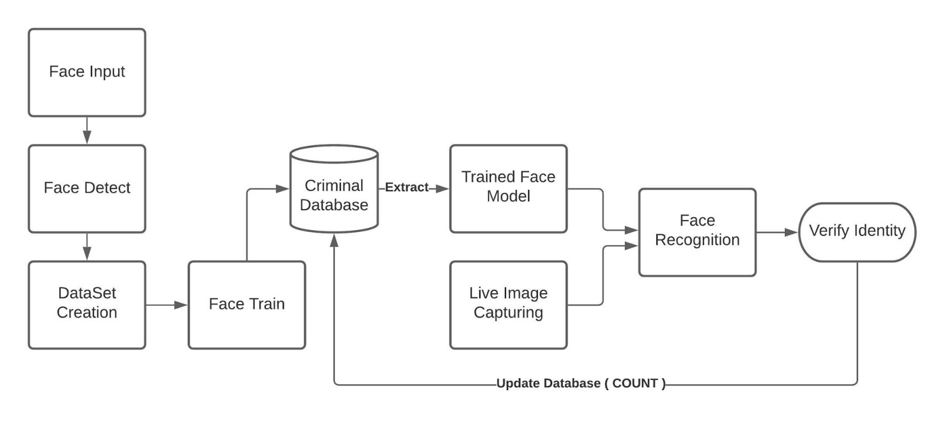

Figure 1: System Block Design

**4.2 Flowchart**

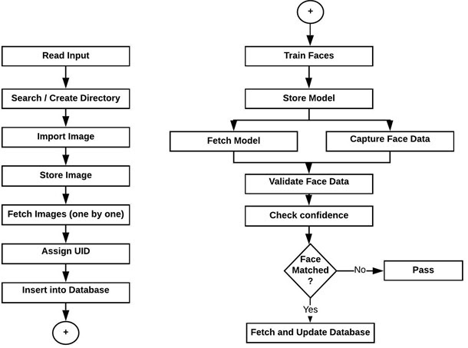

Figure 2: Flowchart diagram

**4.3 Algorithm:**

## Local Binary Patterns Histogram (LBPH):

Local Binary Patterns Histogram algorithm was proposed in 2006. It is based on local binary operator. It is widely used in facial recognition due to its computational simplicity and discriminative power.

The steps involved to achieve this are:

* creating dataset
* face acquisition
* feature extraction
* classification

The LBPH algorithm is a part of opencv.

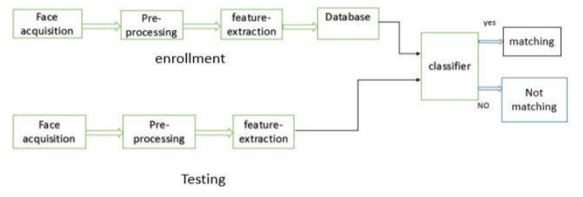

Figure 3: LBPH flowchart

* Suppose we have an image having dimentions N x M.
* We divide it into regions of same height and width resulting in m x m dimension for every region.

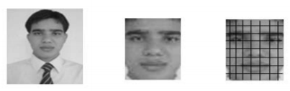

Figure 4: Face window

* Local binary operator is used for every region. The LBP operator is defined in window of 3x3.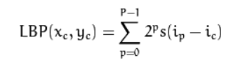
* Here '(Xc,Yc)' is central pixel with intensity 'Ic'. And 'In' being the intensity of the the neighbor pixel
* Using median pixel value as threshold, it compares a pixel to its 8 closest pixels using this function.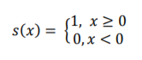

* If the value of neighbor is greater than or equal to the central value it is set as 1 otherwise it is set as 0.
* Thus, we obtain a total of 8 binary values from the 8 neighbors.
* After combining these values we get a 8 bit binary number which is translated to decimal number for our convenience.
* This decimal number is called the pixel LBP value and its range is 0-255.

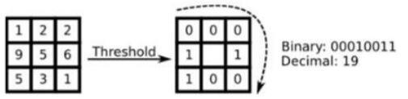

Figure 5: Threshold Conversion

* After the generation of LBP value histogram of the region is created by counting the number of similar LBP values in the region.
* After creation of histogram for each region all the histograms are merged to form a single histogram and this is known as feature vector of the image

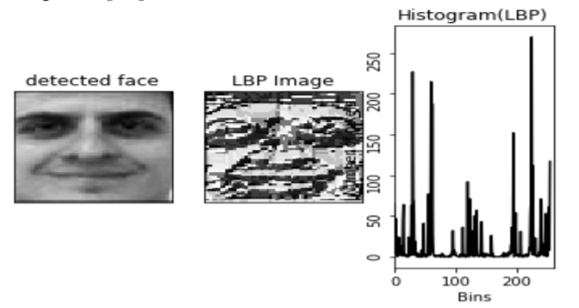

Figure 6: LBPH Conversion

* Now we compare the histograms of the test image and the images in the database and then we return the image with the closest hitogram.  
  ( This can be done using many techniques like euclidean distance, chi-square, absolute value etc )
* The Euclidean distance is calculated by comparing the test image features with features stored in the dataset.The minimum distance between test and original image gives the matching rate

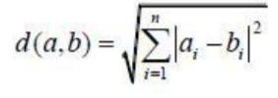

**Chapter 5:**

**Design implementation**

**5.1 Module 1- datasetCreator.py**

In this module which is the first step towards the implementation of the project, here the dataset of the criminals is been created which is been further used in the training process. Here the dataset created using LBPH algorithm, which converts the dataset into the gray scale formatting system, which not only proves to be more efficient as it detecting the features of the respective faces of the criminals but also the multi-color format can sometimes malfunction due to the saturation and heating effect.

In total, it will create a dataset of 501 images is been created and later it will identify in how many pixels the face is detected and the images captured are been trimmed for a better detection of the image purpose.

**5.2 Snap-Shots:**



Figure 7: Snap-shot of dataCreator.py(1)



Figure 8: Snap-shot of dataCreator.py(2)



Figure 9: Snap-shot of dataCreator.py(3)

**5.3 Module 2 – FaceTrain.py**

Face Training and Recognition is the problem of identifying and verifying people in a photograph by their face. It is a task that is trivially performed by humans, even under varying light and when faces are changed by age or obstructed with accessories and facial hair. Nevertheless, it is remained a challenging computer vision problem for decades until recently. Deep learning methods are able to leverage very large datasets of faces and learn rich and compact representations of faces, allowing modern models to first perform as-well and later to outperform the face recognition capabilities of humans. Once the faces of the criminals are trained completely, the local host has to be refreshed in order to update if there have been are criminals added in the database. In this module, it will support multiple types of snap format that is jpg, jpeg and png.

Once the training phase is over, the dataset in the database will be updated, with the current id, name and the number of the times the criminal face is been detected in the system. As the as get detected, the number gets incremented and updated into the database simultaneously.

**5.4 Snap-Shots:**



Figure 10: Snap-shot of FaceTrain.py(1)



Figure 11: Snap-shot of FaceTrain.py(2)



Figure 12: Snap-shot of FaceTrain.py(3)



Figure 13: Snap-shot of FaceTrain.py(4)

**5.5 Module 3 – FaceDetect.py**

Face-detection algorithms focus on the detection of frontal human faces. It is analogous to image detection in which the image of a person is matched bit by bit. Image matches with the image stores in database. Any facial feature changes in the database will invalidate the matching process.

A reliable face-detection approach based on the [genetic algorithm](https://en.wikipedia.org/wiki/Genetic_algorithm) and the [eigen-face](https://en.wikipedia.org/wiki/Eigenface)[[4]](https://en.wikipedia.org/wiki/Face_detection#cite_note-4) technique:

Firstly, the possible human eye regions are detected by testing all the valley regions in the gray-level image. Then the genetic algorithm is used to generate all the possible face regions which include the lips, the nose and the edges of the face.

Each possible face candidate is normalized to reduce both the lighting effect, which is caused by uneven illumination; and the shirring effect, which is due to head movement. The fitness value of each candidate is measured based on its projection on the eigen-faces. After a number of iterations, all the face candidates with a high fitness value are selected for further verification. At this stage, the face symmetry is measured and the existence of the different facial features is verified for each face candidate.

As for time being, only one criminal is detected, that is bhavya, in the database, only the number of detection of criminal bhavya will increment.

**5.6 Snap-Shots:**

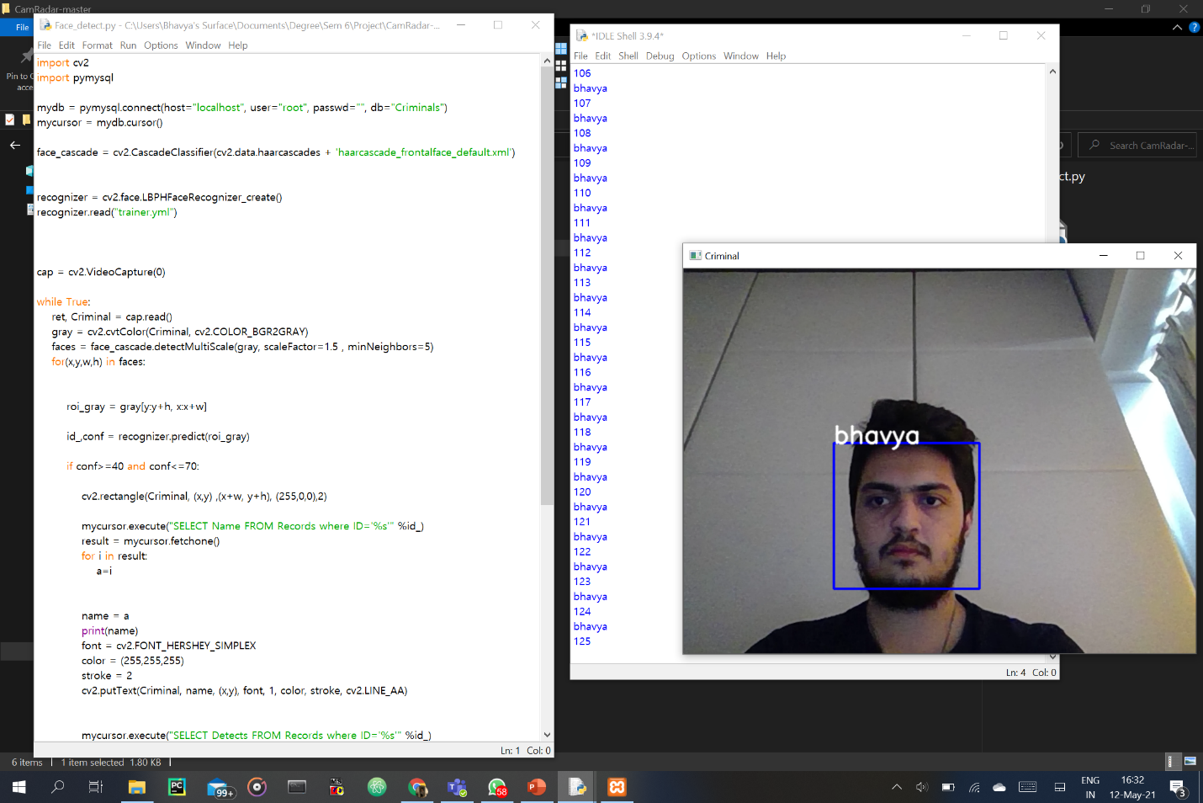

Figure 14: Snap-shot of FaceDetect.py(1)

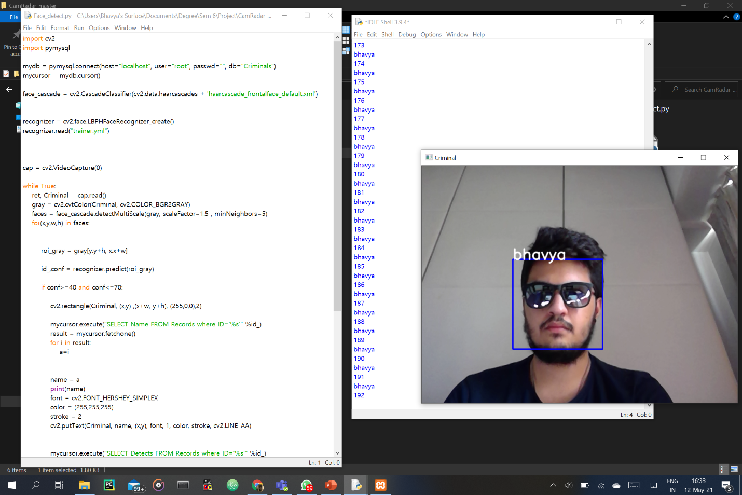

Figure 15: Snap-shot of FaceDetect.py(2)

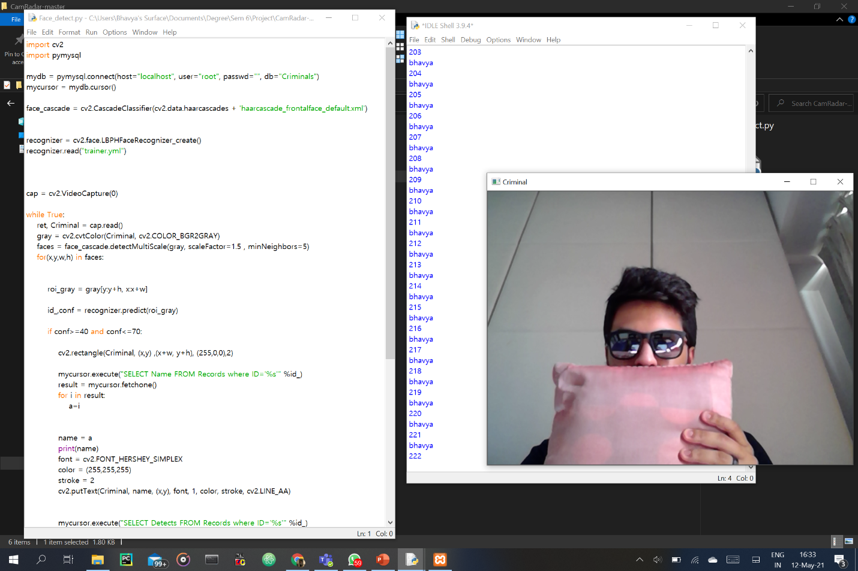

Figure 16: Snap-shot of FaceDetect.py(3)



Figure 17: Snap-shot of FaceDetect.py(4)

**Chapter 7:**

**6.1 Conclusion:**

In this project, we are ready to detect and recognize faces of the criminals in a picture and during a video stream obtained from a camera in real time. we've used Haar feature-based cascade classifiers in OpenCV approach for face detection..

Face recognition technology has come an extended way within the last twenty years. Today, machines are ready to automatically verifies identity for secure transactions and also for surveillance and security tasks, and for access control to buildings etc.

These applications usually add controlled environments and recognition algorithms can cash in of the environmental constraints to get high recognition accuracy. However, next generation face recognition systems are getting to have widespread application in smart environments -- where computers and machines are more like helpful assistants.

To achieve this goal computers must be ready to reliably identify nearby people during a manner that matches naturally within the pattern of normal human interactions. they need to not require special interactions and must conform to human intuitions about when recognition is probably going . this suggests that future smart environments should use an equivalent modalities as humans, and have approximately an equivalent limitations.

These goals now appear in reach however, substantial research remains to be wiped out making person recognition technology work reliably, in widely varying conditions using information from single or multiple modalities.

Cam-Radar team also learnt the importance of machine learning and the way we will really make world a safer place to measure in by using our college learnt engineering concepts.

**6.2 Future Scope:**

* In this project, a facial recognition system for the identification of criminals has been proposed.
* This system will be able to detect the face and recognize face automatically in real-time. Face detection classifiers are shared by open-source communities, such as OpenCV.
* This project demonstrates the generic framework for the face recognition system, and the variants that are frequently encountered by the face recognizer.
* One of the most famous face recognition algorithms, the Local Binary Patterns Histograms(LBPH) algorithm using Haar feature-based cascade classifier is to be used to develop the system.
* Face recognition has its applicability in various ﬁelds. On the basis of results obtained in our analysis, the future scope can be stated as:
  1. Room for improving accuracy: The accuracy for multiclass classiﬁer can be improved.
  2. Various other techniques can be implemented and compared to obtain better accuracy results for a large database.
  3. On getting a better accuracy we can use it in diﬀerent ﬁelds for the purpose of security.
* We can also add features of weapon detection or sentimental analysis for further crime prevention

**References:**

1. Aftab Ahmed,Jiandong Guo,Fayaz Ali,Farha Deeba and Awais Ahmed, ‘ LBPH based improved face recognition at low resolution’ .Chengdu, China:IEEE,2018.

2. Ratna Yustiawati,Nyayu Latifah Husni,Evelina Evelina,Sabilal Rasyad,Iskandar Lunitfi,Ade Silvia,Niksen Alfarizal and Adella Rialita, ‘Analyzing Of Different Features Using Haar Cascade Classifier’. Pangkal Pinang: IEEE,2019.

3. Maliha Khan,Sudeshna Chakraborty,Rani Astya and Shaveta Khepra, ‘Face Detection and Recognition Using OpenCV’. Greater Noida, India: IEEE,2019.

4. Ali Sharifara,Mohd Shafry Mohd Rahim and Yasaman Anisi, ‘ A general review of human face detection including a study of neural networks and Haar feature-based cascade classifier in face detection’. Kuala Lumpur, Malaysia: IEEE,2014.

5. Neel Ramakant Borkar and Sonia Kuwelkar, ‘ Real-time implementation of face recognition system’. Erode, India: IEEE,2017.

6. Lu Song and Fuan Wen, ‘ The Human-Computer Interaction Design and Research of Virtual Experiment’. Hangzhou, China: IEEE,2014.

**Acknowledgement:**

On the submission of our thesis report on “Criminal Detection(CAM-RADAR)”, we would like to extend our gratitude and sincere thanks to our supervisor Prof. Krupa Chotai, Department of Computer Science Engineering for her constant motivation and support during the course of our work in the last one year. We truly appreciate and value his esteemed guidance and encouragement from the beginning to the end of this thesis. We are indebted to him for having helped us shape the problem and providing insights towards the solution.

Above all, we would like to thank all our friends whose direct and indirect support helped us complete our project in time. The thesis would have been impossible without their perpetual moral support.